Create a new branch



List all branches (local & remote)

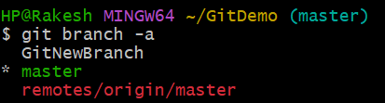

Switch to the new branch

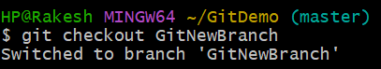

Create and add files





Commit the changes

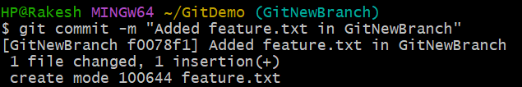

Check status

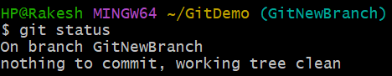

Switch back to master

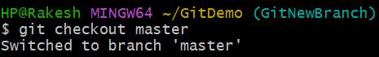

Show command-line differences between branches

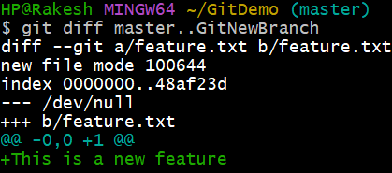

View visual differences using **P4Merge**

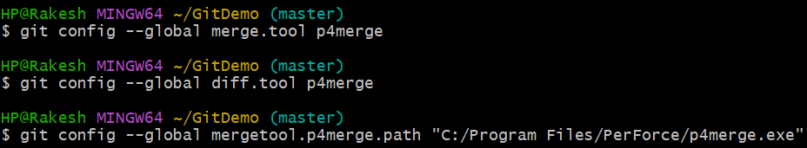

launch visual diff

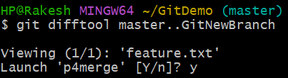

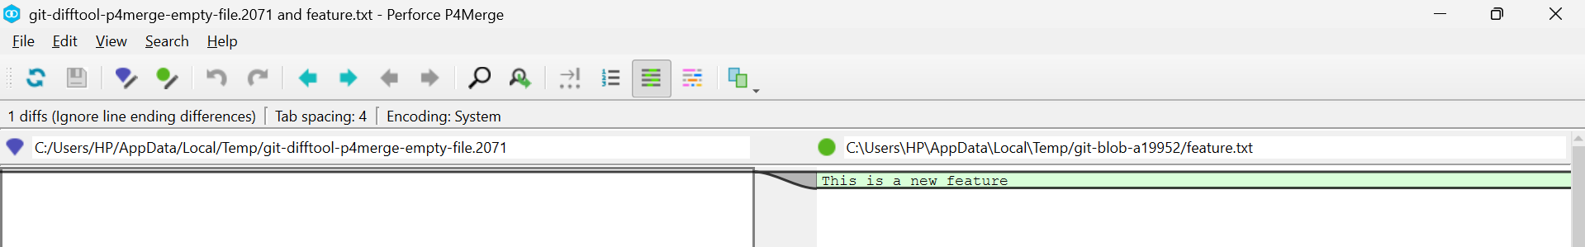

Merge the branch into master

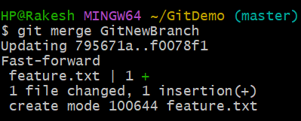

View merge history as a graph

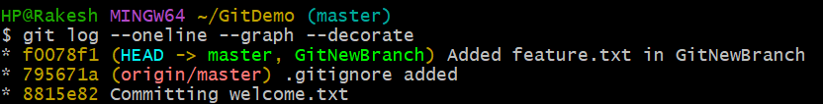

Delete the merged branch

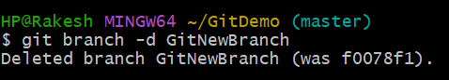

Confirm current branch and status

